A000-Eur-Italy-Roman-Votary Figure-Bronze-ca 200 CE

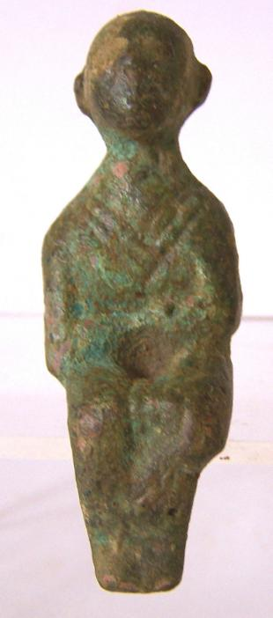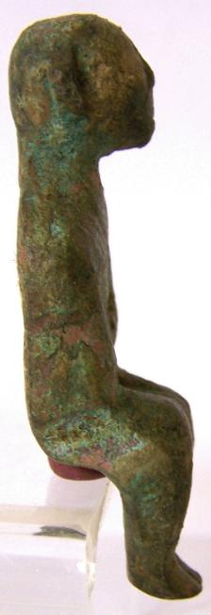

Case no.: 4

Accession Number:

Formal Label: Italy-Roman-Bronze bust-Female

**Display Description:**

**Such bronze figurines were popular as likenesses of family members and in addition as votive objects which soldiers would take on expeditions to remind them of their loved ones at home.**

**LC Classification: C135**

Date or Time Horizon: ca 200 CE

Geographical Area: Rome

**Map:**

**GPS coordinates:**

Cultural Affiliation: Roman Empire

Medium: bronze

Dimensions: : 6.5 cm x 2.2 cm

Weight:

Condition:

Provenance: Old English collection

**Discussion:**

**References:**